September 17th, 2006
Hi
Not much to write about this week.
I only managed to get in two swims instead of three due to wind, rain and thunderstorms on Wednesday as the rain bands of a passing tropical storm affected HK. Still did 4.6 km for the week or 2.3 km per swim. The pool water is a bit cooler now and only a few people are using the pool, at least at the times I go. Therefore, I am now able to use the larger end of the pool again for swimming. On Wednesday, instead of the swim, I did 30 minutes of rowing, the first for a long time. Was averaging 2 min 7.5 sec per 500 km for 20 min (not terribly fast), but in the last 10 minutes I made three brief stops and finished with an average of only 2 min 10.5 sec per 500 km.
Al Gore has been in HK promoting his film and beliefs about global warming.
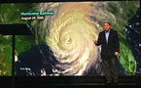
On TV, I watched some of the 9/11 anniversary commemorations live from New York. Being 12 hours ahead of New York, it was quite convenient.
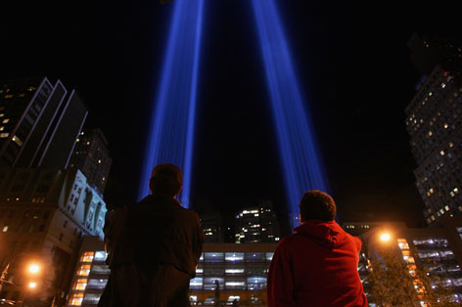
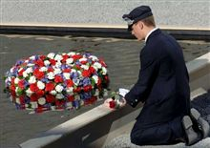

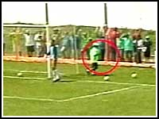

Did you hear about the third division soccer match in Brazil where a ball boy scored a goal? In the 89th minute, a player shot narrowly wide with the ball going into the side netting. The ball landed near a ball boy standing near the post. He stopped the ball, and instead of returning it to the goalkeeper, took a couple of steps onto the pitch and booted it into the net of the visiting team! Although there was nearly 10 seconds between the shot going out and the boy placing the ball over the line, the lady referee awarded a goal! Later, after an appeal, the goal was allowed to stand, although the referee was suspended. All this was recorded on video and shown on the TV news.
On Thursday evening, at about 8 pm, there as a minor earthquake in HK. Only about 3.5 on the Richter scale. Some people felt it. I didn’t, even though I was sitting down, which is when you are more likely to feel an earthquake than if you are moving.
That seems to be it for now.

Cheers

